SHORT KAILASH & MANSAROVAR YATRA EX. LUCKNOW
(05 Nights / 06 Days) Using Helicopter

TRIP OVERVIEW

It is a special yatra tour by both scheduled & special chartered Helicopter flight via Nepalgunj /Simikot and Hilsa. In general we use scheduled flight from Kathmandu to Nepalgunj and Nepalgunj to Simikot. Hilsa fall on rain pro area and chances of whether issues and flight cancellation is higher as compared to other sectors. Simikot is under restricted Dolpo zone area and significantly high entry permit charge is applicable. Kailash Tirtha Yatra Pvt. Ltd. Nepal/ India invite you all the lord Shiv devotees to confirm your seats in time.

Outline itinerary
Day 01 - Pickup from Lucknow. Nepalgunj arrival
Day 02 - Fly Simikot- Hilsa. Drive to Purang (Taklakot)
Day 03 - Rest at Purang (Taklakot)
Day 04 -Drive Purang to Mansarovar & Yam Dwar, Back to Taklakot.
Day 05 - Drive to Hilsa Via Taklakot , Fly Simikot- Nepalgunj
Day 06-Departure from Lucknow.

DETAILED ITINERARY

Day 01- Pickup from Lucknow. Nepalgunj arrival
Pick from Lucknow. Arrival at Nepalgunj. Transfer to Hotel in Nepalgunj. Briefing program about trip, dinner & overnight.

Day 02 - Fly Simikot- Hilsa. Drive to Purang(Taklakot)
Early morning fly to Simikot by domestic airlines. Upon reaching Simikot airport take a flight to Hilsa by Helicopter. Fresh up at local guest house with tea/coffee. Then crossing Karnali bridge arrive to Chinese land. Drive to Purang (Taklakot). Before Purang have immigration formalities at Chinese custom office.

Day 03 - Rest at Purang (Taklakot)
Full day rest day in Purang (Taklakot) for acclimatization purpose. You may do shopping at Purang market.

Day 04 - Drive Purang to Mansarovar & Yam Dwar, Back to Taklakot.
After breakfast, drive to MansarovarLake (4,556 M, 120 KM, 3 hrs drive). Take a holy bath and Puja or just relax at the edge of holy ManasarovarLake. After having holy dip and lunch, you will leave for a MansoravarParikrama – 82 KM, 2 hours drive) around the lake.

Day 05- Drive to Hilsa Via Taklakot , Fly Simikot- Nepalgunj

Morning fly to Simikot by Helicopter. Fly back to Nepalgunj.

Day 06 –Departure from Nepalgunj to lucknow drop (4hrs drive.)

Accommodation:
- accommodation with breakfast, lunch & dinner [Pure veg. Meals] using best available hotel in Nepalgunj in sharing basis.
- Accommodation in Tibet with breakfast lunch & dinner [Pure veg. Meals] using Guest Houses in sharing basis.
- Mineral water throughout Kailash Yatra.
- Nepalgunj / Simikot / Nepalgunj transfer by Air.
- Simikot / Hilsa / Simikot by Helicopter.
- In Tibet, land transfer by luxury bus.
- Supporting truck to carry luggage, food, equipment etc.
- Yak & Yakmen for trekking equipment and food during Kailash Parikarma.
- Highly qualified and experienced Sherpa staff throughout the trip.
- Tibetan Guide.
- Air compressor bag [Gammo Bag].
- First Aid Kit.
- Oxygen Cylinder.
- Tibet & Simikot [Nepal] permit.
- Normal Chinese Visa fee.
- Local Mobile [Chinese] (will be charged as per the use).
- Walky Talky.
- Windcheater Jacket.
- Duffle bag.
- Trip Certificate.

PRICE EXCLUDES
- Tickets to Kathmandu and return.
- Nepal visa for NRIs & foreigners.
- All personal expenses like telephone calls, tips, shopping, laundry, cold/hard drinks etc.
- Personal use of pony/porter during Parikarma [Kora].
- Single room supplement in Kathmandu.
- Any extra services such as extra vehicle / hotel nights / sightseeing tours than mentioned in the itinerary.
- Evacuation cost.
- Travel Insurance.
- Extra cost such as extra night stay than mentioned in the itinerary, ill health, cancellation, changes in itinerary that are incurred due to unforeseen reasons such as road blockage due to landslide, heavy snowfall, strikes, flight cancellation etc.
- Visa splitting charge and extra transportation cost, if returning early from Tibet.
Service which are not mentioned above in inclusion part.

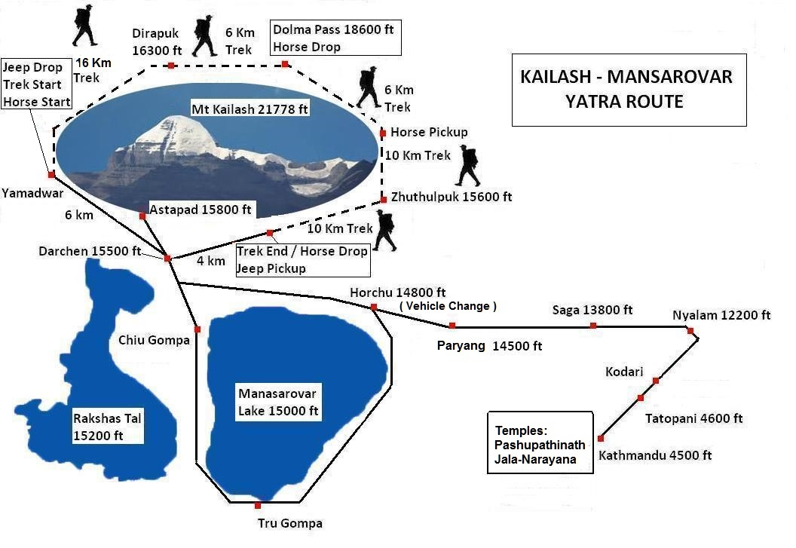

TERMS & CONDITIONS

Payment Terms:

- Initial booking amount of INR 20000 PER PERSON [non-refundable] to be deposited at the time of booking.
- 50% of payment should make 30 days prior to the departure of trip to Tibet.
- All payment should be cleared before the commencement of Trip.

Policy Of Cancellation Of Trip:
- A charge of 10% will be applied for any cancellation made prior to 25 days of departure date.
- A charge of 25% will be applied for any cancellation made prior to 20 days of departure date.
- A charge of 50% will be applied for any cancellation made prior to 10 days of departure date.
- No refund for any cancellation made thereafter.
- Verbal cancellation will not be entertained.

Optional Tour:
If you wish to extend your trip to any pilgrimage site such as Muktinath, Janakpur Dham, Damodar Kund, Kagvusundi Lake etc. or you want to go for any short trips such as Pokhara, Chitwan, Dhulikhel, Nagarkot etc. please ask us.

Risk & Liability
We will do our best to make the tour with safe and smooth. As all the tour programs are conducted strictly under the rules and regulations of Tibet Tourism Bureau (TTB), we will not be accountable for any changes due to change of official rules and laws of Tibet. Moreover Wewill also not be liable for any changes in the itinerary due to unavoidable circumstances such as landslide, road blockage, flood, snow, and political unrest, cancellation of flight, sickness and accidents. Any extra cost arising due to the above circumstances shall be borne by the clients on the spot.
Do's
- For smooth & successful completion of yatra, it is essential to develop good understanding among yatris.
- Do take Diamox regularly till you finish the parikrama.
- Drink plenty of water & fluids during trekking. Take liberal amounts of hot, fluids and enough nourishment to provide energy for body.
- Do cover yourself properly and protect yourself from Cold.
- Use good quality tinted snow-glasses or dark sun glasses to protect eyes against snow blindness. Avoid use of cheap, poor quality sun glasses.
- Apply good quality sunscreen lotion (30 SPF) to exposed parts of the body to avoid sunburn, particularly during parikramas.
- If there is heavy snowfall or snow storms, stay close to each other & avoid being separated.
- Do respect their culture and people.
- Do maintain cleanliness.
- Follow instructions of the Tour officer properly.
Don'ts
Do not neglect to consume sufficient food & fluids. Do remember that pilgrims suffer from loss of appetite at high altitudes. So, per force consume enough nourishment.
Do not over exert. Fatigue can lead to cold and more serious problems, especially at high altitude.
Do not take photographs of Army Officials and Check Post.
Do not talk about Dalai Lama.
Do not smoke or consume alcohol during the yatra & especially at high altitudes, as this is dangerous & has serious consequences.

Passport & Visas
All the travelers should have valid passport for six month and visa can be obtain from Nepalese embassy or consulate in India, however visa is stamp at the time of arrival in Airport. For yatra you get a group visa and we get entry in group as per size. While submitting passport for visa it’s not necessary to send your old passport.

Change/Delay in Program
Sometime due to the unavoidable circumstances like bad climate, political unrest, landslides, health illness, natural disasters which are beyond human control may occur, we will be happy to refer you for any alternative trip to suit you.

Trip leaders
All trips leaders are one of our professional English-Hindi speaking trip leaders who are different from the tour guides our trip leaders are trained they know the areas like their backyards and have explored like dozens of times. With an experience of more than ten years, every one of them has served more than hundreds of guests from all over the world. They are responsible, trustworthy and have their own life experience and story to share which will add more fun and safety to your Kailash Yatra. We put the cost of paying our guides a good wage straight into the tour price so they are happy and not reliant on guest's spending money shopping to earn their own salaries. Thus they concentrate on your needs and being the best hosts to you that possibly can.

ALTITUDE SICKNESS
While going to high altitude Parts of your trips above 2500 meters/9200 feet where it is common for travelers to experience some adverse health effects due to the altitude - regardless of your age, gender and fitness. Take it easy, and follow our suggestions to reduce the sickness effects. The altitude problem is a very common for everyone who arrives at the high altitude region from lower altitude area, but some are affected seriously and some are not, so there is certain way to prevent it or minimize its effect by preparing before you go to highlands. Here we have listed some tips that we had experiences in the past years.
Currency: Only US Dollars & Euros can be exchanged in Yuan for this you may change currency from banks in Tibet to Chinese Yuan, currency used in Tibet or For INR get exchange on your country with Exchange or you can find in Nepal also but as the rates fluctuate almost every day. And buying and selling rate always differ.
Insurance:
We recommend that you insure yourself against sickness, emergency surface or air rescue, accident, trip cancellation, medical treatment, hospitalization etc. We regret that such policies are not available in Nepal.
Communication:
You can make calls from almost everywhere. Tibet has good networking for mobile phones. And during stay at hotels you can use wife if available otherwise you find a Chinese Sim-card on purchase which may cost 200 Yuan.
Clothing, equipment and accessories:
While driving, it will be warm inside the vehicle but windy cold outside. Mornings and evenings will be generally cold therefore warm clothing will be required. We recommend that you bring the following clothing and accessories with you.
Good well worn-in walking shoes.
Warm comfortable trekking boots.
Clothing
Wool shirts
Cotton shirts
Regular underwear
Thermal underwear
Culottes/trousers for women
Trousers/shorts for men
Wind and rain gear with hood
Wool hat/mittens/gloves
Wool and cotton socks
Sweaters
Lined zip jacket/down jacket with hood
Track suit
Sleeping clothes
Accessories
Personal first-aid
Toilet Kit
Flash light/torch with extra batteries
Sun glasses
Water bottle
Swim suit (for use before and after Tibet trip)
Plastic bags for reading material, film, cameras etc
Dust mask, silk scarves for use against dust
Sun block cream and lip salve, sanitizer
Documents
Passport (with photocopies)
Travel Insurance (with photocopies)
Airline Tickets (with photocopies)
Some recent two inch colorized photo
RMB Cash
Credit or debit card

